**Final Project for CSC 122 001 Computer Science II**

**Chapter 19 Programming Challenges 1 – 10**

**From *Starting Out with C++, Early Objects*, 9e by Gaddis, Tony**

**Spring 2018**

**Submitted by Julius Ranoa**

Table of Contents1

**Project 1 Simple Binary Search Tree Class Page 2**

Programming Challenges 1 – 7

A class implementing simple binary search tree capable of storing numbers with certain member functions.

**Project 2 Cousins Page 16**

Programming Challenge 9

Building on Program 19-5, write a function that takes a pointer to a *Person* object and produces a list of that person’s cousins.

**Project 3 Prefix Representation of Binary Trees Page 23**

Programming Challenge 10

A handler class to display the prefix representation of a given binary tree.

1 Programming Challenge 8 Employee Tree had already been submitted as a previous homework assignment and thus is not included in this submission.

Source code can also be found at

<https://github.com/JasonRanoa/SP18-CSC-122>

**Project 1 Simple Binary Search Tree Class**

**Objective:** Write a class for implementing a simple binary search tree capable of storing numbers. The class should have member functions:

*Programming Challenges 1 – 7 are compiled into one project file. The programming challenge the listed method belong to are indicated by a superscript at the end. (e.g. [PC1] for the first programming challenge.)*

1. An insert method that accepts an integer. This method should not use recursion directly or indirectly by calling a recursive function. [PC1]
2. A search method that accepts an integer. The search function should work by calling a private recursive member function. [PC1]
3. An inorder method that accepts a reference to an initially filled vector and fills it with the inorder list of numbers stored in the binary search tree. [PC1]
4. A size method that returns the number of items (nodes) stored in the tree. [PC2]
5. A *leafCount* member function that counts and returns the number of leaf nodes in the tree. Nodes with no children are considered leaf nodes. [PC3]
6. A height method that computes and returns the height of the tree. The height of the tree is the number of levels it contains. [PC4]
7. A width method that computes the width of the tree. The width of the tree is that largest number of nodes at the same level. [PC5]
8. A tree copy constructor. [PC6]
9. An overloaded assignment operator for the tree. [PC7]

All methods are invoked by a driver program to demonstrate correctness.

**Implementation Overview:**

A class named *BinaryTree* contains all the methods required by the challenges. A default constructor and destructor are also added for the clean-up after dynamic allocation.

This documentation will first present the source code for the header and implementation files. In the header file, the programming challenge each public member method fulfills is noted in a comment next to the method declaration. In the implementation file, the method definitions are sorted according to the which programming challenge it is used (either directly or as a helper function).

**Files included**2**:** (1) BinaryTree.h, (2) BinaryTree.cpp

2 The driver program, main.cpp, will be included later. Since there needs to be several demonstrations, multiple versions of the driver program are included.

**Source Code for BinaryTree.h**

#ifndef **CH19_PR1_7_SIMPLE_BINARY_SEARCH_TREE_CLASS_BINARYTREE_H**#define **CH19_PR1_7_SIMPLE_BINARY_SEARCH_TREE_CLASS_BINARYTREE_H**#include **<vector>  
  
class** BinaryTree {  
  
**private**:  
 **struct** TreeNode {  
 **double** value;  
 TreeNode * left;  
 TreeNode * right;  
  
 TreeNode(  
 **double** argVal,  
 TreeNode * argLeft = **nullptr**,  
 TreeNode * argRight = **nullptr** ) {  
 value = argVal;  
 left = argLeft;  
 right = argRight;  
 }  
 };  
  
 TreeNode * root;  
  
 *// Private Methods* **void** destroySubTree(TreeNode *); *// Cleans up dynamic memory allocation* **bool** search(**double** x, TreeNode *);  
 **void** attachinorder(std::vector<**double**> &, TreeNode *);  
 **void** countNodes(**int** &, TreeNode *);  
 **void** countLeaves(**int** &, TreeNode *);  
 TreeNode * duplicateNode(**const** TreeNode *);  
  
**public**:  
 BinaryTree() {  
 root = **nullptr**;  
 }  
 ~BinaryTree() {  
 destroySubTree(root);  
 }  
 **void** insert(**double** x); *// Programming Challenge 1A.* **bool** search(**double** x); *// Programming Challenge 1B.* **void** inorder(std::vector<**double**> &); *// Programming Challenge 1C.* **int** size(); *// Programming Challenge 2* **int** leafCount(); *// Programming Challenge 3* **int** height();*// Programming Challenge 4* **int** width(); *// Programming Challenge 5  
 // Programming Challenge 6 Tree Copy Constructor* BinaryTree(**const** BinaryTree &);  
 *// Programming Challenge 7 Tree Assignment Constructor* BinaryTree & **operator**=(**const** BinaryTree &);  
  
};

**Source Code for BinaryTree.cpp**

#include **<iostream>**#include **"BinaryTree.h"***// CLEANING UP. Destroying subtrees.***void** BinaryTree::destroySubTree(TreeNode * tree) {  
 **if** (!tree) **return**;  
 destroySubTree(tree->left);  
 destroySubTree(tree->right);  
 **delete** tree;  
}  
  
*/*  
 * Programming Challenge 1A  
 * An insert function that does not use recursion,  
 * directly or indirectly by calling a recursive function.  
 *  
 */***void** BinaryTree::insert(**double** x) {  
 */*  
 * This implementation makes use to pointers to pointers,  
 * indicated by the **. This works but there's another way of  
 * doing it that's much easier.  
  
 TreeNode ** ptrToNodePtr = &root;  
  
 while (*ptrToNodePtr) {  
 if ((**ptrToNodePtr).value == x) {  
 return; // Do nothing.  
 } else if (x < (**ptrToNodePtr).value) {  
 ptrToNodePtr = &((**ptrToNodePtr).left);  
 } else {  
 ptrToNodePtr = &((**ptrToNodePtr).right);  
 }  
 }  
  
 *ptrToNodePtr = new TreeNode(x);  
  
 */  
  
 // If tree node is empty...* TreeNode * newNode = **new** TreeNode(x);  
 **if** (!root) {  
 root = newNode;  
 } **else** {  
 *// If the tree node is not empty, we can just append the new item by  
 // changing the value of the left/right pointer.* TreeNode *currentNode, *oneAfter;  
 currentNode = oneAfter = root;  
 *// We have two variables here: (1) currentNode, and  
 // (2) oneAfter -- which is just used to test for nullptr (i.e. insertion points)* **while** (currentNode->value != x && oneAfter != **nullptr**) {  
 currentNode = oneAfter;  
 **if** (x < currentNode->value) {  
 oneAfter = currentNode->left;  
 } **else** {  
 oneAfter = currentNode->right;  
 }  
 }  
  
 **if** (currentNode->value == x) **return**;  
 **else if** (x < currentNode->value) {  
 currentNode->left = newNode;  
 } **else** {  
 currentNode->right = newNode;  
 }  
 *// Do note that we can't assign newNode to oneAfter  
 // since doing so wouldn't affect the node on the tree.* }  
  
 **return**;  
}  
  
*/*  
 * Programming Challenge 1B  
 * Create a search function that works by calling a private  
 * recursive function.  
 *  
 */  
  
// Public Member Function***bool** BinaryTree::search(**double** x) {  
 **return** search(x, root);  
}  
  
*// Private Member Function -- Recursive***bool** BinaryTree::search(**double** x, TreeNode * tree) {  
 **if** (!tree) {  
 **return false**; *// Found end of tree but no match.* } **else if** (tree->value == x) {  
 **return true**;  
 } **else if** (x < tree->value) {  
 **return** search(x, tree->left);  
 } **else** {  
 **return** search(x, tree->right);  
 }  
}  
  
*/*  
 * Programming Challenge 1C  
 * Create an in-order function that accepts an empty vector and fills  
 * it with the in-order list of numbers in the tree.  
 *  
 */***void** BinaryTree::inorder(std::vector<**double**> & v) {  
 attachinorder(v, root);  
}  
  
**void** BinaryTree::attachinorder(std::vector<**double**> & v, TreeNode * tree) {  
 **if** (tree) {  
 attachinorder(v, tree->left);  
 v.push_back(tree->value);  
 attachinorder(v, tree->right);  
 }  
}  
  
*/*  
 * Programming Challenge 2  
 * Get the size of the tree.  
 *  
 */***void** BinaryTree::countNodes(**int** & count, TreeNode * tree) {  
 **if** (!tree) **return**;  
 **else** {  
 count++;  
 countNodes(count, tree->left);  
 countNodes(count, tree->right);  
 }  
}  
  
**int** BinaryTree::size() {  
 **int** count = 0;  
 countNodes(count, root);  
 **return** count;  
}  
  
*/*  
 * Programming Challenge 3  
 * Count the number of leaf nodes (i.e. nodes with no children) on the  
 * tree. In this implementation, two methods are used -- A public method  
 * and a private one for recursion.  
 *  
 */***void** BinaryTree::countLeaves(**int** & leafCount, TreeNode * tree) {  
 **if** (!tree) **return**;  
 **else if** (!tree->left && !tree->right) {  
 leafCount++;  
 } **else** {  
 countLeaves(leafCount, tree->left);  
 countLeaves(leafCount, tree->right);  
 }  
}  
  
**int** BinaryTree::leafCount() {  
 **int** nLeaves = 0;  
 countLeaves(nLeaves, root);  
 **return** nLeaves;  
}  
  
*/*  
 * Programming Challenge 4  
 * The height of tree is the number of levels it contains.  
 *  
 */***int** BinaryTree::height() {  
 std::vector<TreeNode *> currentLevel;  
 std::vector<TreeNode *> nextLevel;  
 **int** height = 0;  
  
 *// Start the count.* **if** (root) currentLevel.push_back(root);  
  
 *// Children nodes.* **while** (currentLevel.size() > 0) {  
 height++;  
 **for** (TreeNode * tree : currentLevel) {  
 **if** (tree->left) nextLevel.push_back(tree->left);  
 **if** (tree->right) nextLevel.push_back(tree->right);  
 }  
 currentLevel = nextLevel;  
 nextLevel.clear();  
 }  
  
 **return** height;  
}  
  
*/*  
 * Programming Challenge 5  
 * The width of a tree is the largest number of nodes at the same level.  
 *  
 */***int** BinaryTree::width() {  
 std::vector<TreeNode *> currentLevel;  
 std::vector<TreeNode *> nextLevel;  
 **int** width = 0;  
  
 *// Start the count.* **if** (root) currentLevel.push_back(root);  
  
 *// Children nodes.* **while** (currentLevel.size() > 0) {  
 width = ( width > currentLevel.size() ) ? width : currentLevel.size();  
 **for** (TreeNode * tree : currentLevel) {  
 **if** (tree->left) nextLevel.push_back(tree->left);  
 **if** (tree->right) nextLevel.push_back(tree->right);  
 }  
 currentLevel = nextLevel;  
 nextLevel.clear();  
 }  
  
 **return** width;  
}  
  
*/*  
 * Programming Challenge 6  
 * Implement a tree copy constructor.  
 *  
 */*BinaryTree::BinaryTree(**const** BinaryTree & copy) {  
 root = duplicateNode(copy.root);  
}  
  
BinaryTree::TreeNode * BinaryTree::duplicateNode(**const** TreeNode * source) {  
 **if** (!source) **return nullptr**;  
 **return new** TreeNode(  
 source->value,  
 ( source->left ) ? duplicateNode(source->left) : **nullptr**,  
 ( source->right ) ? duplicateNode(source->right) : **nullptr** );  
}  
  
*/*  
 * Programming Challenge 7  
 * Implement an overloaded copy constructor.  
 *  
 */*BinaryTree & BinaryTree::**operator**=(**const** BinaryTree & source) {  
 destroySubTree(root); *// Just to cover my bases.* root = duplicateNode(source.root);  
 **return** \***this**;  
}

**Driver Programs and Demonstrations**

1. **Feeding the tree with test data, searching with the tree, displaying the values in order and present tree information (i.e. size, height, width, leaf count)**

The following sample data is fed to the tree:

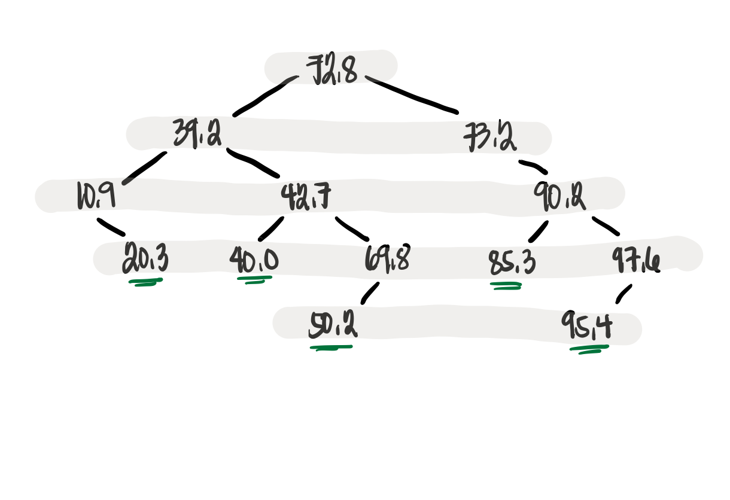

Screenshot of runtime:

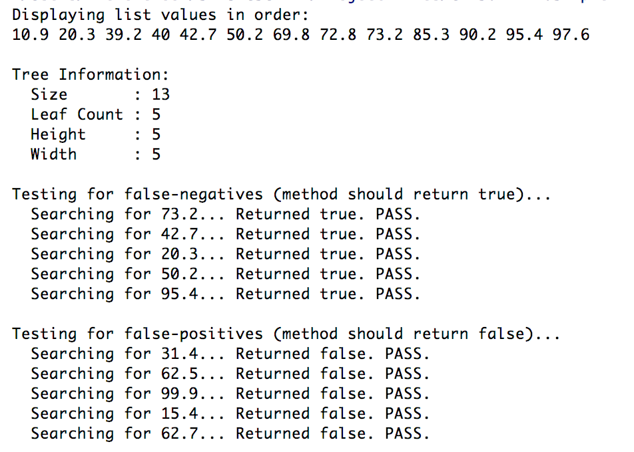

**Source Code for main.cpp**

#include **<iostream>**#include **<sstream>**#include **<vector>**#include **"BinaryTree.h"  
  
void** enterTestData(BinaryTree &);  
  
**int** main() {  
 BinaryTree treeOne;  
 enterTestData(treeOne);  
  
 std::vector<**double**> numList;  
 treeOne.inorder(numList);  
  
 *// Display list* std::cout << **"Displaying list values in order: \n"**;  
 **for** (**double** d : numList) {  
 std::cout << d << **" "**;  
 }  
 std::cout << **"\n\n"**;  
  
 std::cout << **"Tree Information: \n"**;  
 std::cout << **" Size : "** << treeOne.size() << **"\n"**; *// should be 13* std::cout << **" Leaf Count : "** << treeOne.leafCount() << **"\n"**; *// should be 5* std::cout << **" Height : "** << treeOne.height() << **"\n"**; *// should be 5* std::cout << **" Width : "** << treeOne.width() << **"\n"**; *// should be 5* std::cout << **"\n"**;  
  
 *// Testing search functionality* **double** positiveTests[] = { 73.2, 42.7, 20.3, 50.2, 95.4 };  
 std::cout << **"Testing for false-negatives (method should return true)... \n"**;  
 **for** (**double** test : positiveTests) {  
 std::cout << **" Searching for "** << test << **"... "**;  
 **if** (treeOne.search(test)) {  
 std::cout << **"Returned true. PASS. \n"**;  
 } **else** {  
 std::cout << **"Returned false. FAIL. \n"**;  
 }  
 }  
 std::cout << **"\n"**;  
  
 **double** negativeTests[] = { 31.4, 62.5, 99.9, 15.4, 62.7 };  
 std::cout << **"Testing for false-positives (method should return false)... \n"**;  
 **for** (**double** test : negativeTests) {  
 std::cout << **" Searching for "** << test << **"... "**;  
 **if** (treeOne.search(test)) {  
 std::cout << **"Returned true. FAIL. \n"**;  
 } **else** {  
 std::cout << **"Returned false. PASS. \n"**;  
 }  
 }  
  
 **return** 0;  
}  
  
**void** enterTestData(BinaryTree & bin) {  
 std::string testData =  
 **"72.8 39.2 10.9 20.3 42.7 "  
 "40.0 69.8 50.2 73.2 90.2 "  
 "85.3 97.6 95.4"**;  
 std::stringstream ss(testData);  
 **double** temp;  
 **while** (ss >> temp) {  
 bin.insert(temp);  
 }  
 **return**;  
}

1. **Employing the copy constructor and testing for actual duplication of data, not just of pointers.**

The same initial tree is fed to the program. A copy of the tree will be made and additional copies would be inserted. The second tree should have this structure (additional nodes in red):

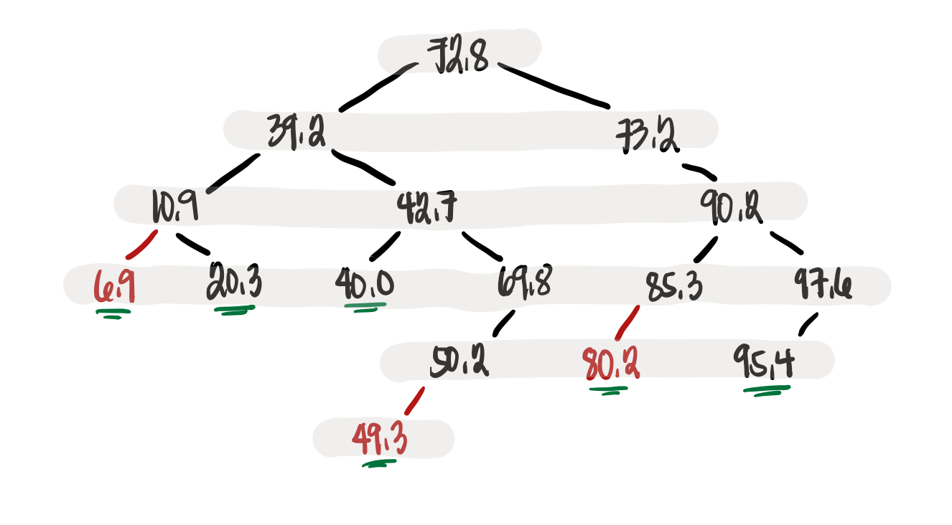

Screenshot of Runtime:

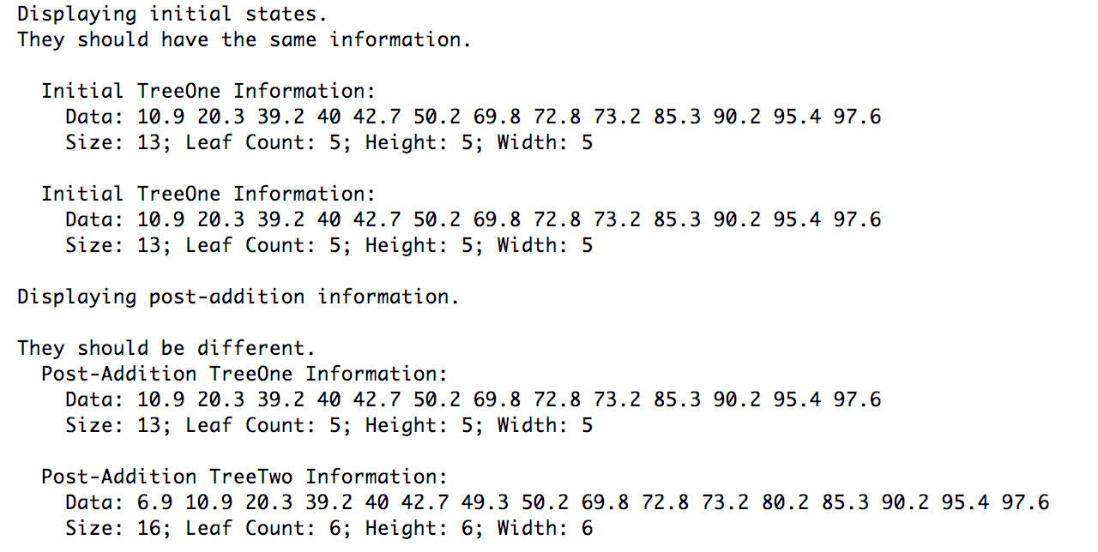

**Source Code for main.cpp**

#include **<iostream>**#include **<sstream>**#include **<vector>**#include **"BinaryTree.h"  
  
void** enterTestData(BinaryTree &);  
**void** displayTreeInfo(BinaryTree * **const**, std::string);  
  
**int** main() {  
 BinaryTree treeOne;  
 enterTestData(treeOne);  
  
 std::vector<**double**> numList;  
 treeOne.inorder(numList);  
 BinaryTree treeTwo = treeOne; *// Uses the copy constructor* std::cout << **"Displaying initial states. \n"  
 "They should have the same information. \n\n"**;  
 displayTreeInfo(&treeOne, **"Initial TreeOne"**);  
 displayTreeInfo(&treeTwo, **"Initial TreeOne"**);  
  
 **double** test[] = { 6.9, 80.2, 49.3 };  
 **for** (**double** d : test) {  
 treeTwo.insert(d);  
 }  
  
 std::cout << **"Displaying post-addition information. \n\n"  
 "They should be different. \n"**;  
 displayTreeInfo(&treeOne, **"Post-Addition TreeOne"**);  
 displayTreeInfo(&treeTwo, **"Post-Addition TreeTwo"**);  
  
 **return** 0;  
}  
  
**void** enterTestData(BinaryTree & bin) {  
 std::string testData =  
 **"72.8 39.2 10.9 20.3 42.7 "  
 "40.0 69.8 50.2 73.2 90.2 "  
 "85.3 97.6 95.4"**;  
  
 std::stringstream ss(testData);  
  
 **double** temp;  
 **while** (ss >> temp) {  
 bin.insert(temp);  
 }  
}  
  
**void** displayTreeInfo(BinaryTree * **const** bin, std::string name) {  
 std::cout << **" "** << name << **" Information: \n"**;  
 std::vector<**double**> dList;  
 bin->inorder(dList);  
 std::cout << **" Data: "**;  
 **for** (**double** d : dList) {  
 std::cout << d << **" "**;  
 }  
 std::cout << **"\n"**;  
 std::cout << **" Size: "** << bin->size() << **"; "**;  
 std::cout << **"Leaf Count: "** << bin->leafCount() << **"; "**;  
 std::cout << **"Height: "** << bin->height() << **"; "**;  
 std::cout << **"Width: "** << bin->width() << **"\n"**;  
 std::cout << **"\n"**;  
}

1. **Using the overloaded assignment operator and testing for actual duplication of nodes, not pointers.**

The third demonstration is an alteration of the second demonstration, employing assignment operators to duplicate trees rather than copy constructors.

A third binary tree, the structure illustrated below, will be used as test data:

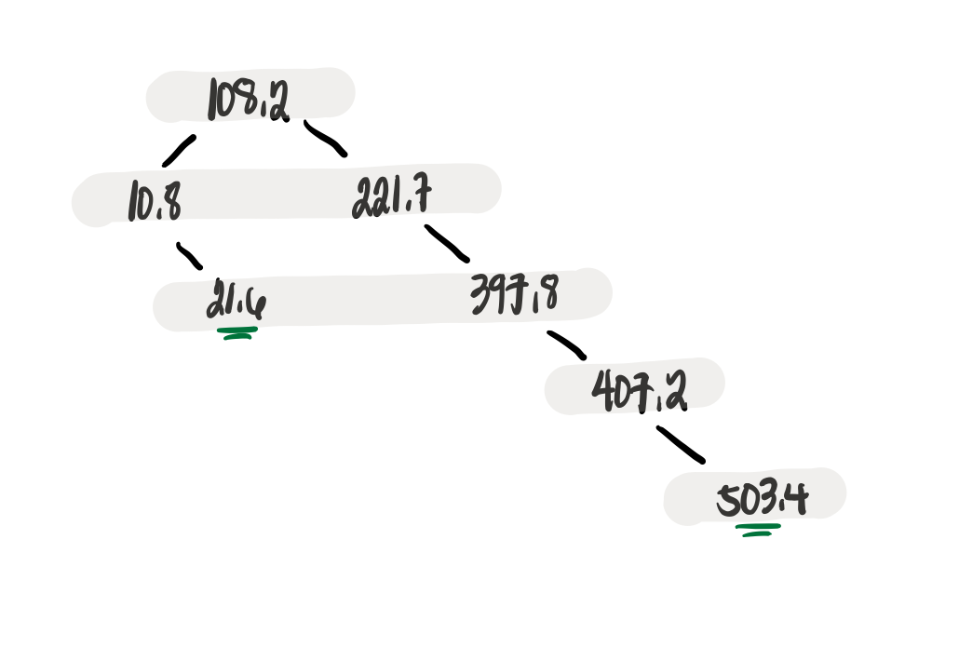

Screenshot of runtime.

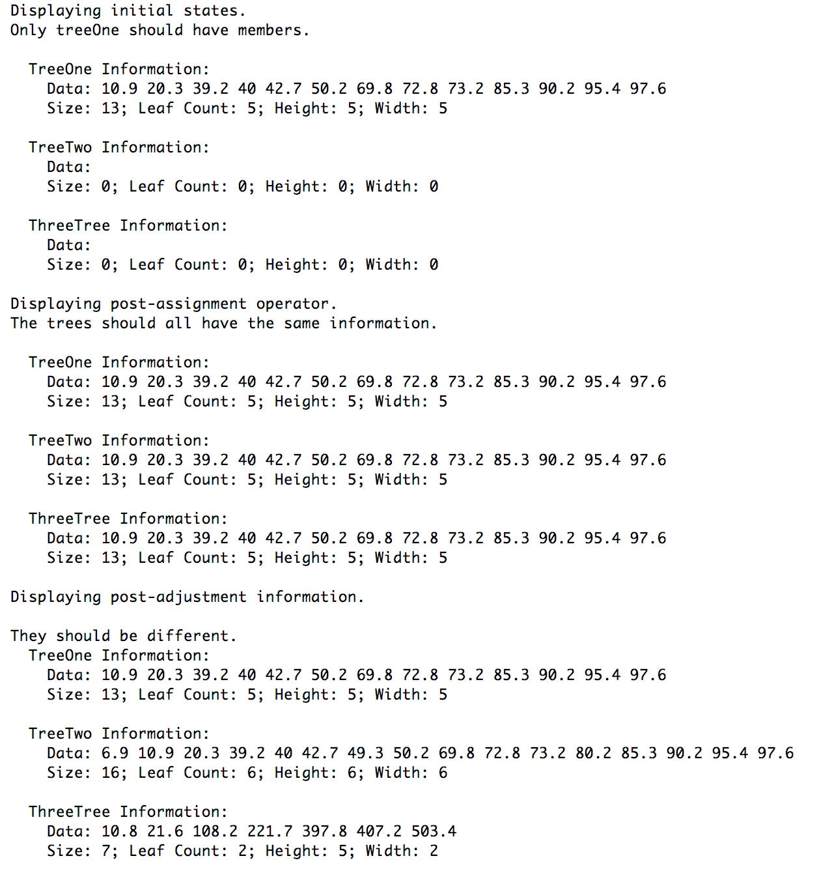

**Source code for main.cpp**

#include **<iostream>**#include **<sstream>**#include **<vector>**#include **"BinaryTree.h"  
  
void** enterTestData(BinaryTree &);  
**void** displayTreeInfo(BinaryTree * **const**, std::string);  
  
**int** main() {  
 BinaryTree treeOne, treeTwo, treeThree;  
 enterTestData(treeOne);  
  
 std::vector<**double**> numList;  
 treeOne.inorder(numList);  
  
 std::cout << **"Displaying initial states. \n"  
 "Only treeOne should have members. \n\n"**;  
 displayTreeInfo(&treeOne, **"TreeOne"**);  
 displayTreeInfo(&treeTwo, **"TreeTwo"**);  
 displayTreeInfo(&treeThree, **"ThreeTree"**);  
  
 treeThree = treeTwo = treeOne; *// this uses an assignment operator.* std::cout << **"Displaying post-assignment operator. \n"  
 "The trees should all have the same information. \n\n"**;  
 displayTreeInfo(&treeOne, **"TreeOne"**);  
 displayTreeInfo(&treeTwo, **"TreeTwo"**);  
 displayTreeInfo(&treeThree, **"ThreeTree"**);  
  
 *// Adding stuff to treeTwo.* **double** testTwo[] = { 6.9, 80.2, 49.3 };  
 **for** (**double** d : testTwo) {  
 treeTwo.insert(d);  
 }  
  
 **double** testThree[] = { 108.2, 221.7, 397.8, 407.2, 503.4, 10.8, 21.6 };  
 treeThree = BinaryTree(); *// Resetting treeTree* **for** (**double** d : testThree) {  
 treeThree.insert(d);  
 }  
  
 std::cout << **"Displaying post-adjustment information. \n\n"  
 "They should be different. \n"**;  
 displayTreeInfo(&treeOne, **"TreeOne"**);  
 displayTreeInfo(&treeTwo, **"TreeTwo"**);  
 displayTreeInfo(&treeThree, **"ThreeTree"**);  
  
 **return** 0;  
}  
  
**void** enterTestData(BinaryTree & bin) {  
 std::string testData =  
 **"72.8 39.2 10.9 20.3 42.7 "  
 "40.0 69.8 50.2 73.2 90.2 "  
 "85.3 97.6 95.4"**;  
  
 std::stringstream ss(testData);  
  
 **double** temp;  
 **while** (ss >> temp) {  
 bin.insert(temp);  
 }  
}  
  
**void** displayTreeInfo(BinaryTree * **const** bin, std::string name) {  
 std::cout << **" "** << name << **" Information: \n"**;  
 std::vector<**double**> dList;  
 bin->inorder(dList);  
 std::cout << **" Data: "**;  
 **for** (**double** d : dList) {  
 std::cout << d << **" "**;  
 }  
 std::cout << **"\n"**;  
 std::cout << **" Size: "** << bin->size() << **"; "**;  
 std::cout << **"Leaf Count: "** << bin->leafCount() << **"; "**;  
 std::cout << **"Height: "** << bin->height() << **"; "**;  
 std::cout << **"Width: "** << bin->width() << **"\n"**;  
 std::cout << **"\n"**;  
}

**Project 2 Cousins**

**Objective:** Building on Program 19-5, write a function that takes a pointer to a *Person* object and produces a list of that person’s cousins.

**Implementation Notes:**

In the project folder, the source code for the *Person* class is included since it’s needed to run the project. Do note that the source code is unmodified and all the work for this project is done in the driver program (i.e. main.cpp). For the sake of completeness, the exported source code will be included as well.

The function with this signature – std::vector<Person *> getCousins(Person *);

contains all the logic needed to extract the cousins from a given Person object, given that relationships have already been defined. Cousins are defined as the children of each parent’s siblings.

The test logic is also already included in the source code. See code comments for more details.

**Screenshot of Runtime:**

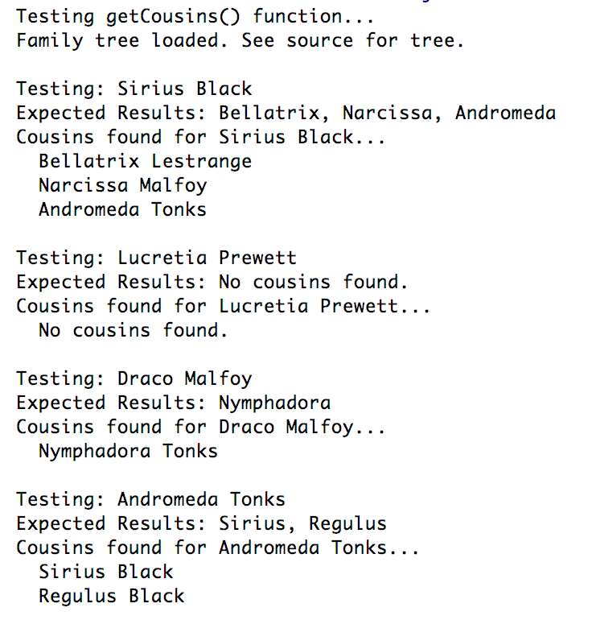

**Files included:** (1) main.cpp, (2) Person.h3, (3) Person.cpp3

3 Taken from *Starting Out with C++, Early Objects 9e*, Gaddis

**Source Code for main.cpp**

#include **<iostream>**#include **<set>**#include **"Person.h"***/*  
 * Programming Challenge 9  
 * Building on Program 19-5, write a function that  
 * takes a pointer to a Person object and produces a list of  
 * that Person's cousins.  
 *  
 * Implementation:  
 * The Person class from Program 19-5 is unmodified.  
 * The getCousins() function is implemented in main.cpp.  
 *  
 */*std::vector<Person *> getCousins(Person *);  
  
std::vector<Person *> produceTestData();  
**void** doTesting(Person *, std::string);  
  
**int** main() {  
 *// Test Data* std::vector<Person *> test = produceTestData();  
  
 std::cout << **"Testing getCousins() function... \n"**;  
 std::cout << **"Family tree loaded. See source for tree. \n\n"**;  
  
 doTesting(test[5], **"Bellatrix, Narcissa, Andromeda"**); *// Sirius* doTesting(test[2], **"No cousins found."**); *// Lucretia* doTesting(test[14], **"Nymphadora"**); *// Draco* doTesting(test[13], **"Sirius, Regulus"**); *// Andromeda  
  
 // Clear test data.* **for** (Person * t : test) {  
 **delete** t;  
 }  
 **return** 0;  
}  
  
std::vector<Person *> getCousins(Person * person) {  
 **if** (!person) **return** std::vector<Person *>();  
 *// Return empty vector.  
  
 // NOTE: Sets are used to avoid name duplication.  
 // The insert function does nothing if key is already there.  
 // Get the list of parents for child.* std::set<Person *> parents;  
 **for** (**int** i = 0; i < person->getNumParents(); i++) {  
 parents.insert(person->getParent(i));  
 }  
  
 *// Get the list of grandparents.* std::set<Person *> grandparents;  
 **for** (Person * parent : parents) {  
 **for** (**int** i = 0; i < parent->getNumParents(); ++i) {  
 grandparents.insert(parent->getParent(i));  
 }  
 }  
  
 *// Get the list of children of the grandparents* std::set<Person *> parentSiblings;  
 **for** (Person * grandparent : grandparents) {  
 **for** (**int** i = 0; i < grandparent->getNumChildren(); ++i) {  
 parentSiblings.insert(grandparent->getChild(i));  
 }  
 }  
 *// Remove the current parents to get list of parent siblings* **for** (Person * parent : parents) {  
 parentSiblings.erase(parent);  
 }  
  
 *// Now, get the children of the p-siblings to get cousins* std::set<Person *> cousinSet; *// To avoid duplication.* **for** (Person * parentSibling : parentSiblings) {  
 **for** (**int** i = 0; i < parentSibling->getNumChildren(); i++) {  
 cousinSet.insert(parentSibling->getChild(i));  
 }  
 }  
  
 **return** std::vector<Person *>(cousinSet.begin(), cousinSet.end());  
}  
  
std::vector<Person *> produceTestData() {  
 */*  
 * Black Family Tree (Test Data)  
 * Arcturus --- Melania Pollux --- Irma  
 * | |  
 * --------- -----------  
 * | | | |  
 * Lucretia Orion --- Walburga Cygnus --- Druella  
 * | |  
 * --------- -------------------------  
 * | | | | |  
 * Sirius Regulus Bellatrix Narcissa Andromeda  
 * | |  
 * Draco Nymphadora  
 *  
 */* std::vector<Person *> people = {  
 **new** Person( **"Arcturus Black III"**, ***male*** ), *// 0* **new** Person( **"Melania Macmillan"**, ***male*** ), *// 1* **new** Person( **"Lucretia Prewett"**, ***female*** ), *// 2* **new** Person( **"Orion Black"**, ***male*** ), *// 3* **new** Person( **"Walburga Black"**, ***female*** ), *// 4* **new** Person( **"Sirius Black"**, ***male*** ), *// 5* **new** Person( **"Regulus Black"**, ***male*** ), *// 6* **new** Person( **"Pollux Black"**, ***male*** ), *// 7* **new** Person( **"Irma Crabbe"**, ***female*** ), *// 8* **new** Person( **"Cygnus Black"**, ***male*** ), *// 9* **new** Person( **"Druella Rosier"**, ***female*** ), *// 10* **new** Person( **"Bellatrix Lestrange"**, ***female*** ), *// 11* **new** Person( **"Narcissa Malfoy"**, ***female*** ), *// 12* **new** Person( **"Andromeda Tonks"**, ***female*** ), *// 13* **new** Person( **"Draco Malfoy"**, ***male*** ), *// 14* **new** Person( **"Nymphadora Tonks"**, ***female*** ), *// 15* };  
  
 *// Establish relationships.* people[0]->addChild(people[2]);  
 people[1]->addChild(people[2]);  
  
 people[3]->addChild(people[5]); people[4]->addChild(people[5]);  
 people[3]->addChild(people[6]); people[4]->addChild(people[6]);  
  
 people[7]->addChild(people[4]); people[7]->addChild(people[4]);  
 people[7]->addChild(people[9]); people[7]->addChild(people[9]);  
  
 people[9]->addChild(people[11]); people[10]->addChild(people[11]);  
 people[9]->addChild(people[12]); people[10]->addChild(people[12]);  
 people[9]->addChild(people[13]); people[10]->addChild(people[13]);  
  
 people[12]->addChild(people[14]);  
 people[13]->addChild(people[15]);  
  
 **return** people;  
}  
  
**void** doTesting(Person * test, std::string expectedResults) {  
 std::vector<Person *> testResults;  
  
 std::cout << **"Testing: "** << test->getName() << **"\n"** << **"Expected Results: "** << expectedResults << **" \n"**;  
 std::cout << **"Cousins found for "** << test->getName() << **"... \n"**;  
 testResults = getCousins(test);  
 **if** (testResults.size() == 0) {  
 std::cout << **" No cousins found. \n"**;  
 } **else** {  
 **for** (Person * p : testResults) {  
 std::cout << **" "** << p->getName() << **"\n"**;  
 }  
 }  
  
 std::cout << **"\n"**;  
}

**Source Code for Person.h**

#ifndef **QUIZ9_PR19_5_DOCUMENTATION_SOURCEFILE_PERSON_H**#define **QUIZ9_PR19_5_DOCUMENTATION_SOURCEFILE_PERSON_H**#include **<vector>**#include **<string>**#include **<iostream>**#include **<cstdlib>  
using namespace** std;  
  
**enum** Gender{***male***, ***female***};  
  
*// Person class represents a person participating in a genealogy.***class** Person  
{  
 string name;  
 Gender gender;  
 vector<Person *> parents;  
 vector<Person *> children;  
 **void** addParent(Person *p){ parents.push_back(p); }  
**public**:  
 Person (string name, Gender g)  
 {  
 **this**->name = name;  
 gender = g;  
 }  
 Person *addChild(string name, Gender g);  
 Person *addChild(Person *p);  
  
 **friend** ostream &**operator** << (ostream &out, Person p);  
  
 *// Member functions for getting various Person info* string getName() **const**{ **return** name; };  
 Gender getGender() **const**{ **return** gender; };  
 **int** getNumChildren() **const**{ **return** children.size(); }  
 **int** getNumParents() **const**{ **return** parents.size(); }  
 Person *getChild(**int** k) **const** ;  
 Person *getParent(**int** k) **const**;  
  
};  
  
#endif *//QUIZ9_PR19_5_DOCUMENTATION_SOURCEFILE_PERSON_H*

**Source Code for Person.cpp**

#include **"Person.h"***//************************************************************  
// Create a child with specified name and gender, and *  
// set one of the parents to be this person. *  
// Add the new child to the list of childfen for this person *  
//\*\*\*\*\*\*\*\*\*\*\*\*\*\*\*\*\*\*\*\*\*\*\*\*\*\*\*\*\*\*\*\*\*\*\*\*\*\*\*\*\*\*\*\*\*\*\*\*\*\*\*\*\*\*\*\*\*\*\*\**Person *Person::addChild(string name, Gender g)  
{  
 Person *child = **new** Person(name, g);  
 child->addParent(**this**); *// I am a parent of this child* children.push_back(child); *// This is one of my children* **return** child;  
}  
  
*//************************************************************  
// Add a child to the list of children for this person *  
//\*\*\*\*\*\*\*\*\*\*\*\*\*\*\*\*\*\*\*\*\*\*\*\*\*\*\*\*\*\*\*\*\*\*\*\*\*\*\*\*\*\*\*\*\*\*\*\*\*\*\*\*\*\*\*\*\*\*\*\**Person *Person::addChild(Person* child)  
{  
 child->addParent(**this**); *// I am a parent of this child* children.push_back(child); *// This is one of my children* **return** child;  
}  
  
*//*********************************************************  
// Return a pointer to the specified parent *  
//\*\*\*\*\*\*\*\*\*\*\*\*\*\*\*\*\*\*\*\*\*\*\*\*\*\*\*\*\*\*\*\*\*\*\*\*\*\*\*\*\*\*\*\*\*\*\*\*\*\*\*\*\*\*\*\*\**Person *Person::getParent(**int** k) **const**{  
 **if** (k < 0 || k >= parents.size())  
 {  
 cout << **"Error indexing parents vector."** << endl;  
 exit(1);  
 }  
 **return** parents[k];  
}  
  
*//**********************************************************  
// Return a pointer to a specified child *  
//\*\*\*\*\*\*\*\*\*\*\*\*\*\*\*\*\*\*\*\*\*\*\*\*\*\*\*\*\*\*\*\*\*\*\*\*\*\*\*\*\*\*\*\*\*\*\*\*\*\*\*\*\*\*\*\*\*\**Person *Person::getChild(**int** k) **const**{  
 **if** (k < 0 || k >= children.size())  
 {  
 cout << **"Error indexing children's vector."** << endl;  
 exit(1);  
 }  
 **return** children[k];  
}  
  
*//****************************************************  
// Overloaded stream output operator *  
//\*\*\*\*\*\*\*\*\*\*\*\*\*\*\*\*\*\*\*\*\*\*\*\*\*\*\*\*\*\*\*\*\*\*\*\*\*\*\*\*\*\*\*\*\*\*\*\*\*\*\*\**ostream & **operator**<<(ostream & out, Person p)  
{  
 out << **"<person name = "** << p.name << **">"** << **'\n'**;  
 **if** (p.parents.size() > 0)  
 out << **" <parents>"** << **' '**;  
 **for** (**int** k = 0; k < p.parents.size(); k++)  
 {  
 out << **" "** << p.parents[k]->name << **' '**;  
 }  
 **if** (p.parents.size() > 0)  
 out << **" </parents>"** << **"\n"**;  
 **if** (p.children.size() > 0)  
 out << **" <children>"** << **' '**;  
 **for** (**int** k = 0; k < p.children.size(); k++)  
 {  
 out << **" "** << p.children[k]->name << **' '**;  
 }  
 **if** (p.children.size() > 0)  
 out << **" </children>"** << **"\n"**;  
 out << **"</person>"** << **"\n"**;  
 **return** out;  
}

**Project 3 Prefix Representation of Binary Trees**

**Objective:** Write a method that prints the prefix representation of binary trees.4

4 See code comments in the main.cpp file for more information.

**Implementation Notes:**

The project asked to modify the main function of Program 19-4 but the provided class – *IntBinaryTree –* doesn’t have a method that allows an external function access to the information needed to fulfill this challenge. Solving this issue would require modifying the source for the *IntBinaryTree* class so I’ve decided to create a method of the *IntBinaryTree* to print the prefix representation.

Most of the code in the *IntBinaryTree* class remains unchanged except for the last few lines. In the header file, a private method named *treePrint()* with 2 arguments and a public method also named *treePrint()* but without any arguments are included. The latter is defined inline but the definition of the first method is in the last few lines of the implementation file. Comments are added to indicate this.

For brevity, snippets of the declaration and definition of the mentioned functions are included below:

**From IntBinaryTree.h**

**private**:  
 **void** treePrint(TreeNode *, std::ostream &);  
  
**public**:  
 **void** treePrint() { treePrint(root, std::cout); };

**From IntBinaryTree.cpp**

**void** IntBinaryTree::treePrint(IntBinaryTree::TreeNode * tree, std::ostream & out) {  
 **if** (!tree) out << **"_"**;  
 **else** {  
 out << **"("** << tree->value;  
 treePrint(tree->left, out);  
 out << **","**;  
 treePrint(tree->right, out);  
 out << **")"**;  
 }  
}

There are six test cases for the demonstration. All are defined in the source code below.

**Screenshot of Runtime:**

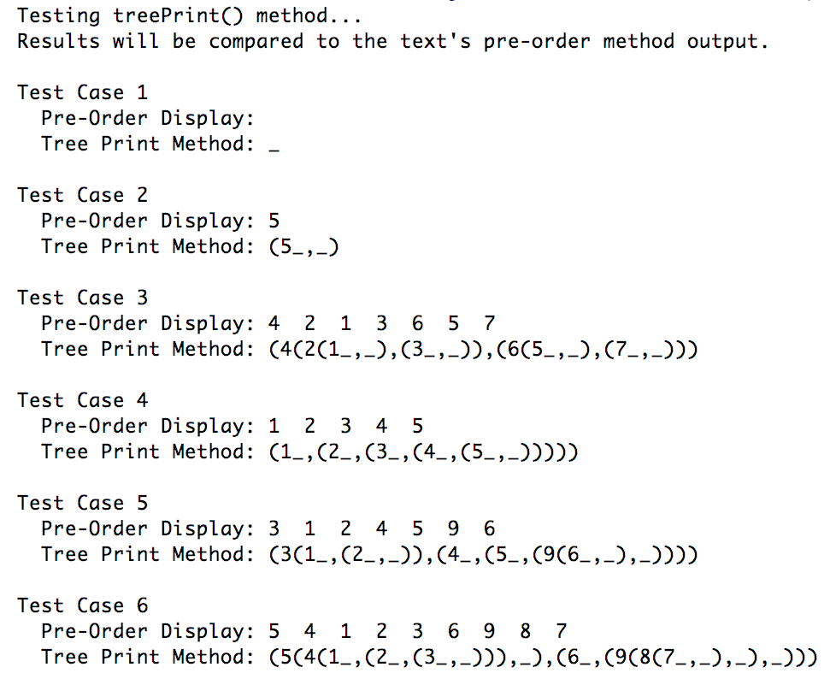

**Files Included:** (1) main.cpp, (2) IntBinaryTree.h5, (3) IntBinaryTree.cpp5

5 Most of the source code taken from *Starting Out with C++, Early Objects 9e*, Gaddis, as part of the challenge requirement.

**Source Code for main.cpp**

#include **<iostream>**#include **<vector>**#include **"IntBinaryTree.h"***/*  
 * Programming Challenge 10  
 * Prefix Representation of Binary Trees  
 *  
 * Rules:  
 * 1. The prefix representation of an empty binary tree is a single underscore.  
 * 2. The prefix presentation of a non-empty binary tree is (v L, R),  
 * where v represents the value stored in root and  
 * L and R are the prefix representations of the left and right subtrees.  
 *  
 * Modify the binary tree class of Program 19-1 to add the ff. member functions.  
 * 1. void treePrint():  
 * This public member function will print the prefix representation of a  
 * binary tree object to standard output.  
 * 2. void treePrint(TreeNode * root, ostream& out) const:  
 * This private member function will print the prefix representation of the  
 * binary tree with a given root to a given output stream.  
 *  
 */***int** main() {  
 *// Loading test data* std::vector<std::vector<**int**>> testPool = {  
 { }, *// intentionally kept empty* { 5 }, *// (5_,_)* { 4, 2, 6, 1, 3, 5, 7 }, *// 4 leaf nodes, 3 levels.* { 1, 2, 3, 4, 5 }, *// Only one leaf node.* { 3, 1, 4, 5, 9, 2, 6 }, *// First seven digits of pi* { 5, 4, 6, 1, 2, 3, 9, 8, 7 } *// Tree forms a diamond.* };  
  
 std::cout << **"Testing treePrint() method... \n"**;  
 std::cout << **"Results will be compared to the text's pre-order method output. \n\n"**;  
  
 **for** (**int** i = 0; i < testPool.size(); ++i) {  
 IntBinaryTree tree;  
 **for** (**int** num : testPool[i]) { tree.insert(num); }  
  
 std::cout << **"Test Case "** << (i + 1) << **"\n"**;  
 std::cout << **" Pre-Order Display: "**;  
 tree.showPreOrder();  
 std::cout << **"\n"**;  
 std::cout << **" Tree Print Method: "**;  
 tree.treePrint();  
 std::cout << **"\n\n"**;  
 }  
  
 **return** 0;  
}

**Source Code for IntBinaryTree.h**

**class** IntBinaryTree  
{  
**private**:  
 *// The TreeNode struct is used to build the tree.* **struct** TreeNode  
 {  
 **int** value;  
 TreeNode *left;  
 TreeNode *right;  
 TreeNode(**int** value1,  
 TreeNode *left1 = **nullptr**,  
 TreeNode *right1 = **nullptr**)  
 {  
 value = value1;  
 left = left1;  
 right = right1;  
 }  
 };  
  
 TreeNode *root; *// Pointer to the root of the tree  
  
 // Various helper member functions.* **void** insert(TreeNode *&, **int**);  
 **void** destroySubtree(TreeNode *);  
 **void** remove(TreeNode *&, **int**);  
 **void** makeDeletion(TreeNode *&);  
 **void** displayInOrder(TreeNode *) **const**;  
 **void** displayPreOrder(TreeNode *) **const**;  
 **void** displayPostOrder(TreeNode *) **const**;  
  
**public**:  
 *// These member functions are the public interface.* IntBinaryTree() *// Constructor* {  
 root = **nullptr**;  
 }  
 ~IntBinaryTree() *// Destructor* {  
 destroySubtree(root);  
 }  
 **void** insert(**int** num)  
 {  
 insert(root, num);  
 }  
 **bool** search(**int**) **const**;  
 **void** remove(**int** num)  
 {  
 remove(root, num);  
 }  
 **void** showInOrder(**void**) **const** {  
 displayInOrder(root);  
 }  
 **void** showPreOrder() **const** {  
 displayPreOrder(root);  
 }  
 **void** showPostOrder() **const** {  
 displayPostOrder(root);  
 }  
  
*// Programming Challenge 10 Method Declarations***private**:  
 **void** treePrint(TreeNode *, std::ostream &);  
  
**public**:  
 **void** treePrint() { treePrint(root, std::cout); };  
  
};

**Source Code for IntBinaryTree.cpp**

#include **<iostream>**#include **"IntBinaryTree.h"  
using namespace** std;  
  
*//**************************************************  
// This version of insert inserts a number into *  
// a given subtree of the main binary search tree. *  
//\*\*\*\*\*\*\*\*\*\*\*\*\*\*\*\*\*\*\*\*\*\*\*\*\*\*\*\*\*\*\*\*\*\*\*\*\*\*\*\*\*\*\*\*\*\*\*\*\*\****void** IntBinaryTree::insert(TreeNode * &tree, **int** num)  
{  
 *// If the tree is empty, make a new node and make it  
 // the root of the tree.* **if** (!tree)  
 {  
 tree = **new** TreeNode(num);  
 **return**;  
 }  
  
 *// If num is already in tree: return.* **if** (tree->value == num)  
 **return**;  
  
 *// The tree is not empty: insert the new node into the  
 // left or right subtree.* **if** (num < tree->value)  
 insert(tree->left, num);  
 **else** insert(tree->right, num);  
}  
  
*//***************************************************  
// destroySubTree is called by the destructor. It *  
// deletes all nodes in the tree. *  
//\*\*\*\*\*\*\*\*\*\*\*\*\*\*\*\*\*\*\*\*\*\*\*\*\*\*\*\*\*\*\*\*\*\*\*\*\*\*\*\*\*\*\*\*\*\*\*\*\*\*\****void** IntBinaryTree::destroySubtree(TreeNode *tree)  
{  
 **if** (!tree) **return**;  
 destroySubtree(tree->left);  
 destroySubtree(tree->right);  
 *// Delete the node at the root.* **delete** tree;  
}  
  
*//***************************************************  
// searchNode determines if a value is present in *  
// the tree. If so, the function returns true. *  
// Otherwise, it returns false. *  
//\*\*\*\*\*\*\*\*\*\*\*\*\*\*\*\*\*\*\*\*\*\*\*\*\*\*\*\*\*\*\*\*\*\*\*\*\*\*\*\*\*\*\*\*\*\*\*\*\*\*\****bool** IntBinaryTree::search(**int** num) **const**{  
 TreeNode *tree = root;  
  
 **while** (tree)  
 {  
 **if** (tree->value == num)  
 **return true**;  
 **else if** (num < tree->value)  
 tree = tree->left;  
 **else** tree = tree->right;  
 }  
 **return false**;  
}  
  
*//********************************************  
// remove deletes the node in the given tree *  
// that has a value member the same as num. *  
//\*\*\*\*\*\*\*\*\*\*\*\*\*\*\*\*\*\*\*\*\*\*\*\*\*\*\*\*\*\*\*\*\*\*\*\*\*\*\*\*\*\*\*\****void** IntBinaryTree::remove(TreeNode *&tree, **int** num)  
{  
 **if** (tree == **nullptr**) **return**;  
 **if** (num < tree->value)  
 remove(tree->left, num);  
 **else if** (num > tree->value)  
 remove(tree->right, num);  
 **else** *// We have found the node to delete.* makeDeletion(tree);  
}  
  
*//***********************************************************  
// makeDeletion takes a reference to a tree whose root *  
// is to be deleted. If the tree has a single child, the *  
// the tree is replaced by the single child after the *   
// removal of its root node. If the tree has two children *  
// the left subtree of the deleted node is attached at *  
// an appropriate point in the right subtree, and then *  
// the right subtree replaces the original tree. *  
//\*\*\*\*\*\*\*\*\*\*\*\*\*\*\*\*\*\*\*\*\*\*\*\*\*\*\*\*\*\*\*\*\*\*\*\*\*\*\*\*\*\*\*\*\*\*\*\*\*\*\*\*\*\*\*\*\*\*\****void** IntBinaryTree::makeDeletion(TreeNode *&tree)  
{  
 *// Used to hold node that will be deleted.* TreeNode *nodeToDelete = tree;  
  
 *// Used to locate the point where the  
 // left subtree is attached.* TreeNode *attachPoint;  
  
 **if** (tree->right == **nullptr**)  
 {  
 *// Replace tree with its left subtree.* tree = tree->left;  
 }  
 **else if** (tree->left == **nullptr**)  
 {  
 *// Replace tree with its right subtree.* tree = tree->right;  
 }  
 **else** *//The node has two children* {  
 *// Move to right subtree.* attachPoint = tree->right;  
  
 *// Locate the smallest node in the right subtree  
 // by moving as far to the left as possible.* **while** (attachPoint->left != **nullptr**)  
 attachPoint = attachPoint->left;  
  
 *// Attach the left subtree of the original tree  
 // as the left subtree of the smallest node  
 // in the right subtree.* attachPoint->left = tree->left;  
  
 *// Replace the original tree with its right subtree.* tree = tree->right;  
 }  
  
 *// Delete root of original tree* **delete** nodeToDelete;  
}  
  
*//*********************************************************  
// This function displays the values stored in a tree *   
// in inorder. *  
//\*\*\*\*\*\*\*\*\*\*\*\*\*\*\*\*\*\*\*\*\*\*\*\*\*\*\*\*\*\*\*\*\*\*\*\*\*\*\*\*\*\*\*\*\*\*\*\*\*\*\*\*\*\*\*\*\****void** IntBinaryTree::displayInOrder(TreeNode *tree) **const**{  
 **if** (tree)  
 {  
 displayInOrder(tree->left);  
 cout << tree->value << **" "**;  
 displayInOrder(tree->right);  
 }  
}  
  
*//*********************************************************  
// This function displays the values stored in a tree *  
// in inorder. *  
//\*\*\*\*\*\*\*\*\*\*\*\*\*\*\*\*\*\*\*\*\*\*\*\*\*\*\*\*\*\*\*\*\*\*\*\*\*\*\*\*\*\*\*\*\*\*\*\*\*\*\*\*\*\*\*\*\****void** IntBinaryTree::displayPreOrder(TreeNode *tree) **const**{  
 **if** (tree)  
 {  
 cout << tree->value << **" "**;  
 displayPreOrder(tree->left);  
 displayPreOrder(tree->right);  
 }  
}  
  
*//*********************************************************  
// This function displays the values stored in a tree *  
// in postorder. *   
//\*\*\*\*\*\*\*\*\*\*\*\*\*\*\*\*\*\*\*\*\*\*\*\*\*\*\*\*\*\*\*\*\*\*\*\*\*\*\*\*\*\*\*\*\*\*\*\*\*\*\*\*\*\*\*\*\****void** IntBinaryTree::displayPostOrder(TreeNode *tree) **const**{  
 **if** (tree)  
 {  
 displayPostOrder(tree->left);  
 displayPostOrder(tree->right);  
 cout << tree->value << **" "**;  
 }  
}  
  
*// Programming Challenge 10 Definition***void** IntBinaryTree::treePrint(IntBinaryTree::TreeNode * tree, std::ostream & out) {  
 **if** (!tree) out << **"_"**;  
 **else** {  
 out << **"("** << tree->value;  
 treePrint(tree->left, out);  
 out << **","**;  
 treePrint(tree->right, out);  
 out << **")"**;  
 }  
}